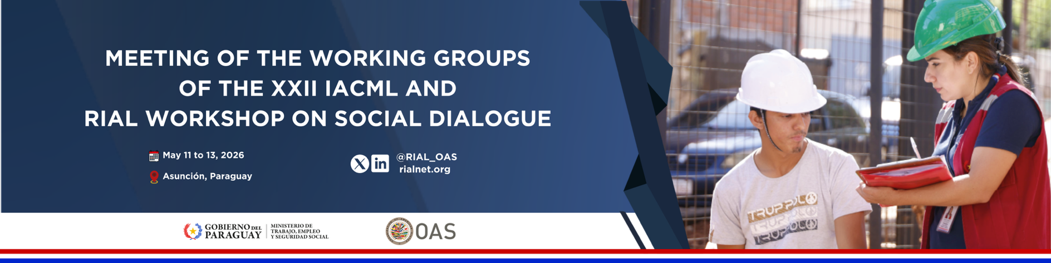

HEMISPHERIC WORKSHOP

INTER-AMERICAN NETWORK FOR LABOR ADMINISTRATION (RIAL)

“Institutionalized Social Dialogue in the Americas: Contributions to Public Policy Making”

Asuncion, Paraguay – May 13th, 2026

https://rialnet.org/?q=en/WorkshopSocialDialogue_Paraguay

Description: This Workshop is an activity under the Work Plan 2025–2027 of the Inter-American Conference of Ministers of Labor (IACML) of the OAS, jointly organized by the Ministry of Labor, Employment and Social Security of Paraguay and the Inter-American Network for Labor Administration (RIAL), with the participation of the Trade Union Technical Advisory Council (COSATE) and the Business Technical Advisory Committee on Labor Matters (CEATAL). It will be held in conjunction with the IACML Meeting of the Working Groups, taking place on May 11–12.

The Workshop will build on the conclusions and recommendations of the RIAL Workshop “Social Dialogue for a Sustainable, Just and Equitable Recovery,” held in Bogotá in July 2022, which highlighted the role of social dialogue as a key tool for defining public policies, strengthening social cohesion and democratic governance, and building a future of work with social justice and sustainable development. Building on these outcomes, the Workshop will enable the identification of progress made since 2022 in the institutionalization of social dialogue at the regional level. The event also responds to the commitments set out in the Declaration and Plan of Action of Bogotá, adopted at the XXII IACML in 2024, including:

“We underscore our commitment to tripartism and social dialogue to achieve a new social contract in the region, for a future of work that is just, equitable, inclusive, environmentally-sustainable, and human-centered.” (Article 7 of the Declaration of Bogotá)

In addition, within the framework of the XXII IACML, Ministers of Labor reaffirmed their commitment to strengthening and institutionalizing social dialogue in the Americas, as well as promoting it as a means to inform and guide the definition of public policy, particularly in the following key areas: new forms of employment, progress towards fair and sustainable energy transitions, skills development systems and reskilling programs, reforms to social protection systems, and wage-setting mechanisms, among others. (Articles 13, 19, and 21 of the Declaration of Bogota and Articles 6.a, 8.a, 8.f, and 8.l of the Plan of Action)

General objective: To increase the knowledge and strengthen the capacities of the Ministries of Labor and social actors to strengthen and institutionalize social dialogue and thereby facilitate consensus-building in the definition of public policies.

Specific objectives:

- Identify progress, achievements, and challenges in the processes of strengthening and institutionalizing social dialogue.

- Exchange and analyze successful experiences of social dialogue that have resulted in the definition of public policies, particularly in emerging areas of the world of work, such as work in digital platforms, the impact of artificial intelligence, and just transition processes, among others.

- Analyze the functioning of mechanisms linked to wage setting, as well as the role of social dialogue, based on the exchange of experiences and relevant cases, in order to identify good practices and opportunities for institutional strengthening.

- Develop policy recommendations to strengthen and institutionalize social dialogue and facilitate consensus-building.

AGENDA

9:00 – 9:10 Welcome remarks and introduction

- Authorities from the Ministry of Labor, Employment and Social Security of Paraguay and the OAS

9:10 – 10:30 1st Session – Institutionalized social dialogue: progress, lessons, and recommendations (Session based on Guiding Question 1)

- Introductory presentation by the OAS (10 minutes)
- Presentations by:
  - 2 Ministries of Labor (10 minutes each)
  - COSATE and CEATAL (10 minutes each)
- Open dialogue among all delegations (30 min)
Guiding Question:

- Based on your country's experience, what are the main successes, challenges, and recommendations regarding the processes to institutionalize and strengthen social dialogue? What progress has been made in this area in your country? In your response, please consider the recommendations for strengthening social dialogue put forward at the 2022 RIAL Workshop.
10:30 – 12:15 2nd Session – Social dialogue and public policies to respond to the transformation of the world of work
(Session based on Guiding Question 2)

- Presentations of 3 national experiences with tripartite participation (15 minutes each)
- Break (15 minutes)
- Open dialogue among all delegations (45 minutes)

Guiding Question:

- Within the framework of social dialogue mechanisms in your country, are there examples of public policies that have resulted from tripartite negotiation processes? If your answer is affirmative, what are the most recent examples, and what have been the key elements in reaching these agreements? If your answer is negative, what challenges have been encountered, and how could they be overcome?

12:00 – 13:30 3rd Session – Social dialogue and wage-setting mechanisms
(Session based on Guiding Question 3)

- Introductory presentation by the ILO (10 minutes)
- Presentations by:
  - 2 Ministries of Labor (10 minutes each)
  - COSATE and CEATAL (10 minutes each)
- Open dialogue among all delegations (30 min)

Guiding Question:

- How are wage-setting mechanisms structured and implemented in practice in your country? What role does social dialogue play in these processes, and what experiences or lessons learned could be shared to strengthen them?

13:30 – 14:00 Closing Session (Ministry of Labor, Employment and Social Security of Paraguay and OAS)

14:00 – 15:00 Farewell Lunch – offered to all participants by the organizers

