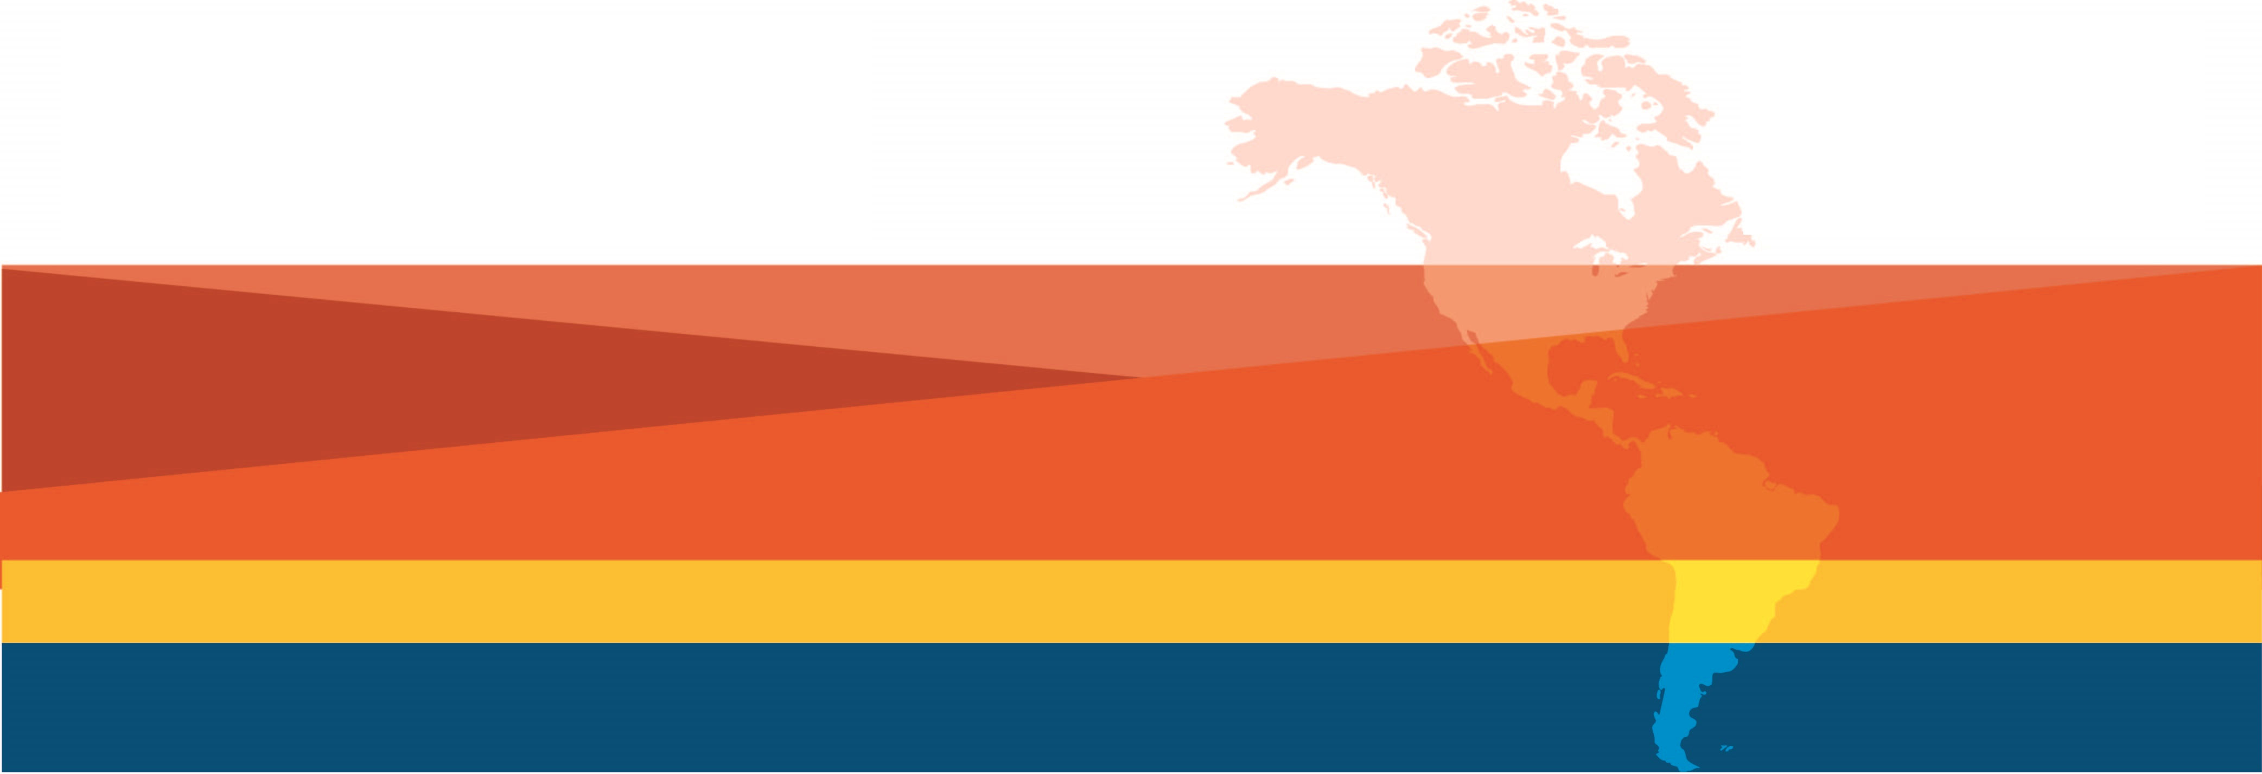
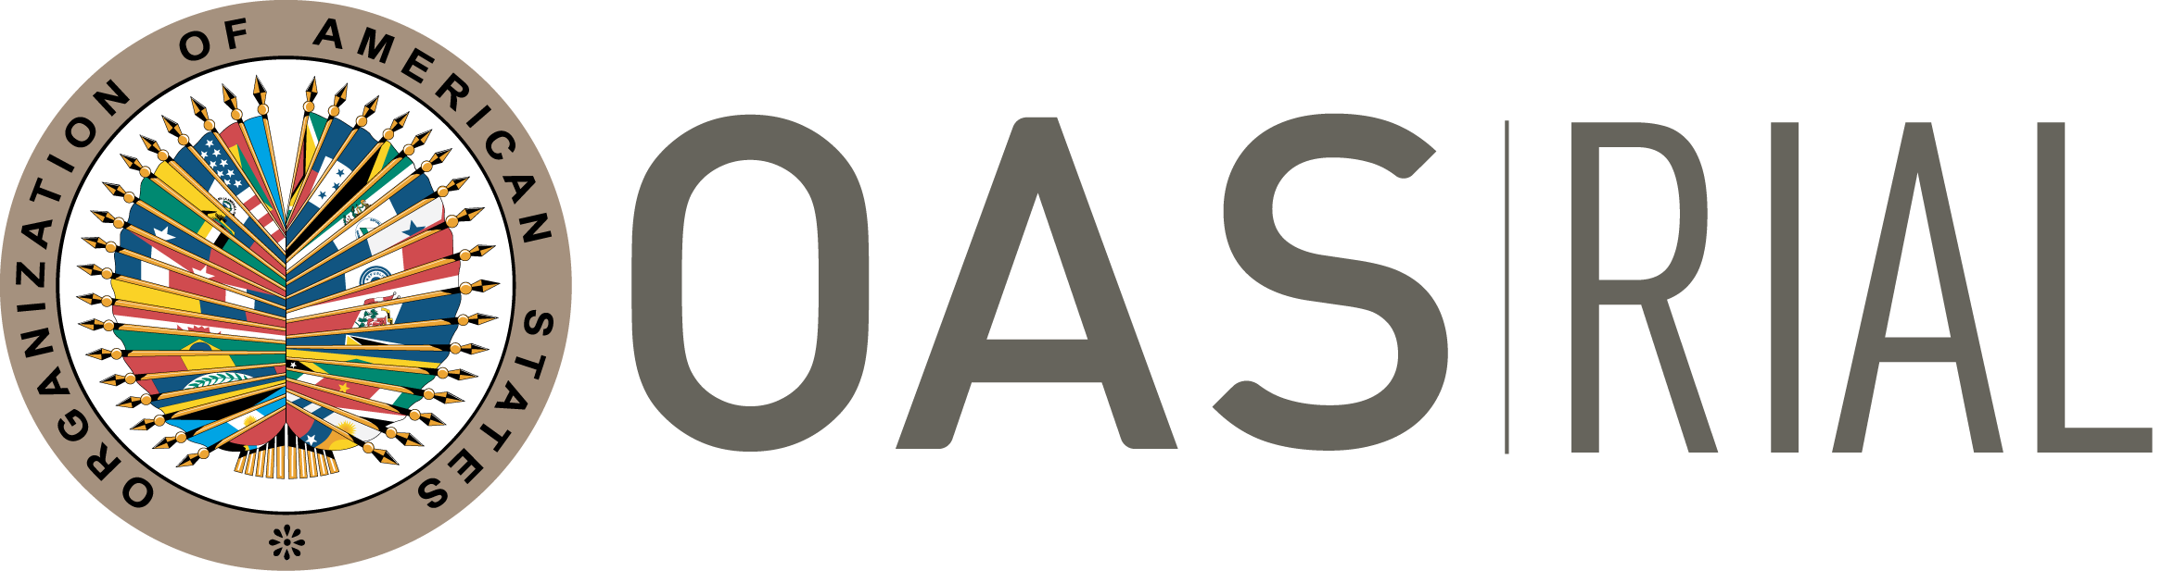
RIAL BILATERAL COOPERATION
14TH Call for virtual activities – 2021
Submission deadline: March 5th, 2021
EXTENDED!
New deadline: March 15th

Webinar to solve questions and support proposal development: February 17. Save the date!
Cooperation among Ministries of Labor of the Americas to strengthen their actions, policies and programs.
We invite all Ministries of Labor to submit proposals.

14th CALL FOR PROPOSALS - GENERAL GUIDELINES

objective AND Description

The objective of “Bilateral Cooperation” under the RIAL is to support institutional strengthening of the Ministries of Labor through direct technical cooperation among them. RIAL has organized 115 activities of this nature with excellent results that include the development of new services, the improvement of existing programs, and the redesign of training activities, among other. All the results and activities can be found in the webpage: www.rialnet.org.

From the 1st Call for proposals and up to the 12th Call in 2019, financial support provided by RIAL covered travel expenses for up to five days for representatives of the Ministries of Labor to receive/provide training in the partner country. During the 13th Call in 2020, given the pandemic, the activities took place virtually and resources were allocated to cover the platform and simultaneous interpretation when required.

The 14th Call will open for Virtual Cooperation Activities only, considering the restrictions that may continue throughout the year for official travel due to the COVID-19 pandemic. All activities will be funded by the RIAL Voluntary Contribution Fund, and those that address specifically efforts to improve labor law compliance will be funded by the Canadian contribution to the RIAL.

For the purpose of bilateral cooperation, the parties involved are:

  - Providing institution: Ministry of Labor that will share a specific program or expertise, and/or provide training or technical assistance.

  - Requesting institution: Ministry of Labor that will analyze a specific program or practice, or that will receive technical cooperation.

The activities are generically called “Cooperation Activities”

operation and procedures

- Identification of Cooperation Activity by the Parties Involved: The first step that should be taken by a requesting institution is to determine its international cooperation needs, based on its institutional priorities.

Example: A Ministry has among its priorities or strategic plan the restructuring or creation of a particular area, or the reform of certain internal procedures. To achieve these goals, it wishes to analyze similar experiences from other Ministries and receive international technical cooperation.

The second step is to identify the Ministry that can provide this technical support. To do so, Ministries may consult the RIAL Portfolio of Programs at www.rialnet.org and identify experiences that respond to their cooperation needs and priorities. They should also take advantage of the relationships among RIAL focal points as well as the information and contacts obtained during workshops and meetings of the OAS Inter-American Conference of Ministers of Labor (IACML), ILO or other relevant fora, where delegates have the opportunity to meet, exchange ideas and identify possible channels for further cooperation.

NOTE : For this Call, a fundamental third step is for the Requesting Institution to analyze and ensure that the objectives it pursues are achievable through a VIRTUAL cooperation activity.

- Proposal development – Complete “Request form”: The RIAL focal points should negotiate the cooperation proposals and support technical areas of their Ministries in identifying experiences and potential providers, based on their institutional strengthening needs and priorities. The Technical Secretariat, at the Department of Human Development, Education and Employment of the Executive Secretariat for Integral Development of the OAS (SEDI/OAS), will support the identification of possible providing institutions and will facilitate the interaction between Ministries that do not already have direct communication channels.

The Technical Secretariat will organize a Webinar in English on February 17th to assist Ministries in the presentation of proposals, and contribute to identifying possible partners.

During the negotiation process, it is suggested that the requesting institution completes the Request Form and shares it with the potential providing institution, so that they can understand better the justification and objectives, and decide how to better support the requesting institution. Once an agreement is reached between both institutions, the providing institution could input into the Request Form in order to improve it.

The providing institution will send the requesting institution the letter mentioned in point “c” of the following section, confirming its commitment to undertake the cooperation activity, in case the proposal is selected.

- Proposal submission: Each Requesting institution must submit to the SEDI/OAS, through its RIAL focal point and Permanent Mission to the OAS, a request form or each cooperation activity it wishes to undertake. This request should contain the following documents:
    - Request Form – Attached to this document.
    - A letter from the requesting institution addressed to the RIAL Technical Secretariat, signed by the Minister or a High-ranking official, sending the Request Form and stating the commitment to provide a Final Report of the cooperation activity, in case the proposal is selected.
    - A letter from the providing institution, signed by the Minister or a high-ranking official, addressed to the requesting institution, confirming the commitment to undertake the cooperation activity. This letter should also include the commitment of the providing institution to feed into the Final Report prepared by the requesting institution.

Complete applications should be received no later than March 15th, 2021.

NOTE: For the proposals to be correctly registered, the Technical Secretariat should receive all three documents through the Permanent Mission of the country to the OAS.

- Selection of Cooperation Activities to be funded: The OAS will receive and select the activities to be funded, based on the criteria listed below. Selections are final and not subject to appeal.

The criteria to select the activities are:
  - Pertinence and timeliness of the cooperation - the justification/rationale for the activity shows why cooperation is required at the time
  - Objectives are clear, pertinent and achievable through virtual cooperation activities.
  - Clarity and relevance of the participants’ profiles
  - Explicit commitment on the part of the parties involved
  - Degree of relevance of the topic for the IACML
  - Priority will be given to proposals arising from activities of the RIAL and the IACML, and to those that are receiving co-financing from the requesting institution

Note on ineligibility: The Ministries that have not submitted final reports from previous activities or follow-up surveys will not be eligible to receive new cooperation resources.

- Undertaking and Funding of Cooperation Activities: Activities of this call for proposals will take place virtually between May and December, 2021, and those that are not completed at the end of this period will be canceled.

The Technical Secretariat, after announcing the proposals selected, will contact each of the Ministries involved to jointly set the dates, draft the agendas and coordinate all logistical and technical aspects.

Each activity’s agenda should respond to the interests and needs of the requesting institution and to the strengths of the providing institution; therefore, it should be drafted jointly by the officers that will participate in the cooperation activity from both institutions, in coordination with the RIAL focal point of each Ministry and the Technical Secretariat.

The cooperation sessions will take place through the “ZOOM” Platform of the Department of Human Development, Education and Employment, with the technical and logistical support of the Technical Secretariat, and will be fully recorded. In the case that a selected activity requires simultaneous interpretation, the Technical Secretariat will provide this service.

The activities will typically last three virtual sessions with a minimum space of two weeks between each one. Each virtual session will last between three and four hours. Prior to the first session and between each subsequent ones, reports, documents, and specific questions to be addressed during the sessions will be exchanged.

Benefits of having a virtual bilateral cooperation
- Opportunity of sharing all relevant information (documents, presentations, legal framework, among others) prior to the cooperation and between sessions.
- More space between sessions – which allows for real walkthrough from the providing institution in the process that the requesting institution is pursuing, and not only during the 5-day on-site mission. Thus, the providing institution will be able to see and analyze advancements from its counterpart.
- Possibility to involve more officers
- Possibility to have more sessions (3 sessions)

- Final Reports: Within one month after each of the activities takes place, the requesting institution should produce a Final Report, describing the main outcomes, achievements and lessons learned, as well as future steps to be taken. The providing institution will provide input to and feedback on the report before it is submitted to the Technical Secretariat.

- Follow-up: Six months after the completion of the activity, the OAS will send a follow-up survey to identify the results and impacts of the cooperation. The OAS will prepare a summary report of completed activities, and the achieved results will be presented during the IACML meetings.

A Webinar will take place on February 17th to address questions and support proposal development. In the meantime, for any questions please contact María Claudia Camacho, RIAL Coordinator at mcamacho@oas.org, Tel: (1202) 370-4952 or Guillermo Calzada, RIAL project officer at gcalzada@oas.org, Tel: (1202) 370-9717

RIAL BILATERAL COOPERATION
REQUEST FORM – 14th CALL FOR PROPOSALS - 2020
To be sent no later than March 15th, 2021 to:

Executive Secretariat for Integral Development (SEDI), OAS
Att. Maria Claudia Camacho, Chief of the Labor & Employment Section, RIAL Coordinator
E-mail: trabajo@oas.org; mcamacho@oas.org - Tel: (1202) 370-4952/9717

To complete your submission please send the following along with this request form: Letter from the requesting institution and letter from the providing institution with the details indicated in the Guidelines of this Call for proposals (section “2: Request for funding”)

(The area of the cells is expandable. Please use all the space you consider necessary)
Requesting institution (include country): | Providing institution (include country):
Thematic area of cooperation activity requested:
Justification: Briefly specify why this cooperation is needed at this point in time, state the specific challenges your Ministry is facing in the area that is covered by this cooperation activity and the reasons for choosing the providing institution.
General objective and specific objectives of this virtual cooperation: Please list precise, clear and achievable general objective and specific objectives
Expected results of this cooperation: Please indicate concrete actions your Ministry expects to undertake as a result of this cooperation
Proposed contents for this cooperation: Describe the activity (on-site advising or experts visit), specifying its contents as much as possible (programs to be analyzed, Ministry’s areas to visit, etc.)
Participants’ profiles: Indicate which officers will travel to participate in this cooperation (up to 3 officers). Specify the titles and main responsibilities; it is not necessary to provide names.
Specification of other support: Please indicate if your institution has requested or received financial or technical assistance from international agencies or governments in the area of this cooperation.
Identification of Providing institution: Please indicate how the providing institution was identified, for example RIAL Portfolio of Programs, direct contact, publication or Workshop/Seminar.
Co-financing: Will additional funding be provided (other than RIAL)?
___ No
___ Yes. Please specify: ___________________
Contact information (Name, title, e-mail and phone of individual preparing this request):

RIAL focal points are generally the offices of international affairs or cooperation of the Ministries of Labor. An updated list of focal points is available in the RIAL website: www.rialnet.org .

