COOPERATION EXCHANGE REPORT
Technical cooperation on Youth Employment from the Ministry of Labour & Social Security of Jamaica to the Ministries of Labour of Barbados, Grenada, Saint Kitts & Nevis and St. Lucia

September, 10th to 14th 2018
Kingston, Jamaica

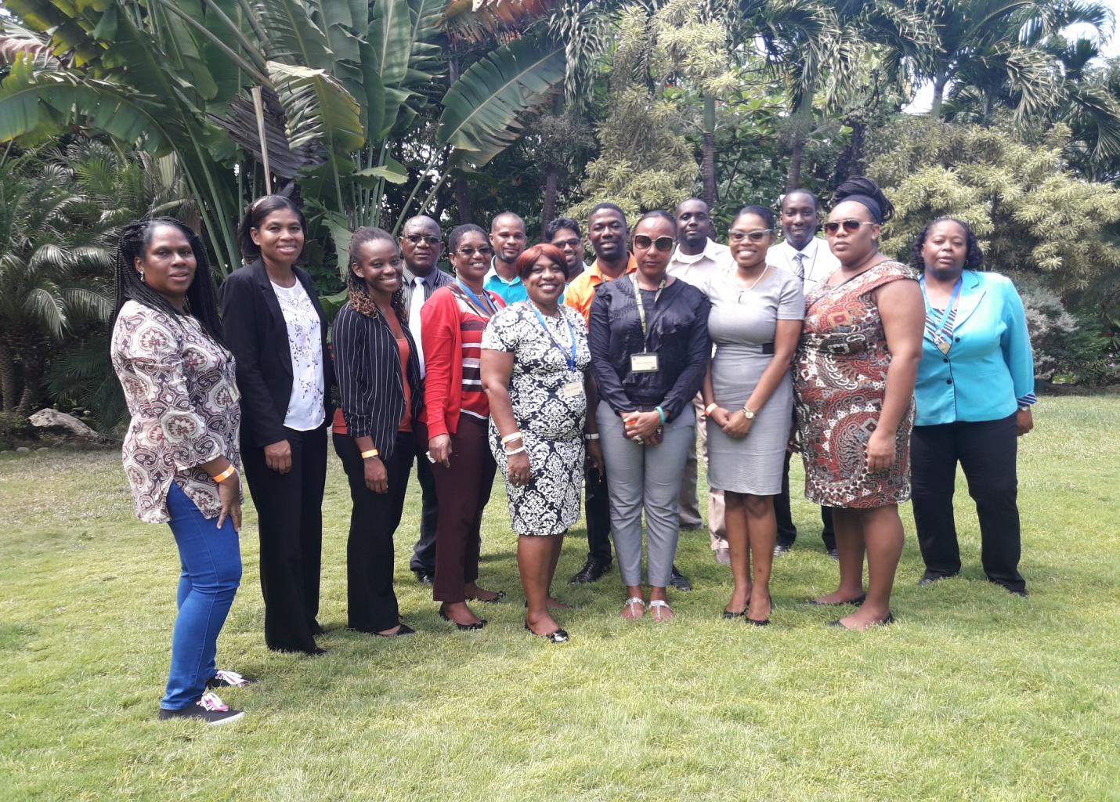
By
CELESTINE ALEXANDER

Brief description of the activity
The Organization of American States Participated on behalf of the Labour Department in a cooperation exchange with Jamaica on youth employment in the framework of the Inter- American Network of Labour Administration (RIAL) on 10-14 September, 2018.
The exchange was part of a series of presentations and study tours which provided opportunities to interact with the young persons who were placed with organizations by the Electronic Labour Exchange (ELE). This On the Job Training (OJT) Programme, from the perspective of the participating employers covers all the main initiatives developed by Jamaica to address the challenges of youth employment. It is against this backdrop that the cooperative exchange was held to understudy the practices, systems, challenges and opportunities; discuss the role of research in designing effective policies and interventions; identify evidence gaps and research priorities, explore opportunities for coordination among key stakeholders to improve the livelihoods of young people.
The five –day exchange was designed to give voice to all those involved with the youth including the youth themselves and their economic and social advancement through the world of work. With this in mind, the last two days were dedicated to providing an opportunity for the delegation to interact with the youth; sharing their experiences and identifying their priorities, whist the youth participants shared their collective experiences and recommendations.
The delegation and the Electronic Labour Exchange (ELE) team respected each other and opinions, focused on processes not individuals, everyone was supportive rather than judgemental, although there were different levels of knowledge and experiences. The Electronic Labour Exchange (ELE) facilitated the tour. There were discussions of its facilities, highlighting the various approaches and many stakeholders who have come on board to assist in alleviating unemployment in general and more specifically to provide solutions to challenges associated with the transition from school to work.

The members of the delegation included the following:
- Permanent Secretary - Grenada
- Deputy Permanent Secretary - Barbados
- Senior Placement & Counselling Officer - Barbados
- Administrative Officer - Barbados
- Acting Labour Commissioner - St. Kitts
- Employment Officer - St. Lucia

Main results and findings
Agriculture
Agriculture which employs the vast majority of the youth in the rural areas in Jamaica is seen as both a challenge and an opportunity for employment and improved income thus facilitating both financial and economic independence. The country enjoys abundant supplies of good arable land that is used to provide livelihoods for the youth. One of the successful stakeholders engaged in agro-business invited the delegation to interact and observe their systems and policies. The stakeholder also shared their experiences; one of their limitations was the rural- urban migration and the youth complained about the distances they had to travel (cost of transportation).
St. Lucia lacks agro-processing industries and this represents potential to attract young people back to agriculture in a way that also helps modernise the sector. This can be replicated in St Lucia because there is a huge untapped potential in services to agricultural activities such as farming, animal husbandry and fishing that today’s unemployed and underemployed youth can take advantage of in St Lucia. There are many parts of the country that produce fruits, such as mangoes and oranges, where much of the crop ends up being rotten because of lack of processing services. There is an obvious gap here for young people to set up their own agriculture-linked enterprises for the benefit of the entire community.
Recognising the potential of agriculture for unemployed young people and raising income levels in Jamaica, the Rural Youth Economic Empowerment Programme (RYEEP) was formed to promote entrepreneurship and self employment. This is perceived by many young people in Jamaica as a possibility for achieving financial independence and economic stability. Through partnership with stakeholders, the programme seeks to develop and support agricultural based entrepreneurship.
Expected outcome:
- Strengthen employability/ core entrepreneur skills.
- Exhibit commitments to volunteering and be supported by a mentor.
Underemployment
Underemployment is a serious problem and one that deprives young people of the ability to reach financial independence. Secondary and tertiary level graduates are unable to find positions commensurate with their level of education. The situation is even worse for the many that fail to complete formal education or who do so with sufficient grasp in the skills they need to enter the labour market. Some of the reasons for this lie with the expectations and preference of young people.
Education and Workforce Training
Education and workforce training: Provision is made to offer quality training and assessment opportunities to desirous Jamaicans where they would obtain a skill in an occupational area for betterment of a productive workplace. This individual will also obtain either a Caribbean Vocational Qualification or National Vocational Qualification of Jamaica (CVQ/NVQJ) which certifies the given skill sectors with job readiness, soft skill and entrepreneurship skills.
This training provided by the Jamaican Government in collaboration with training facilities and youth organizations has a positive impact on the workforce in Jamaica especially the youth. Representatives of the private sector and the youth present at the exchange/ workshop cited the mismatch between the education offered in the formal education system and the needs of the workplace.
Expected outcome:
- Develop technical skills as per programme area.
- Strengthen employability/ core and entrepreneurship skills.
- Exhibit commitments to volunteering and be supported by a mentor.
Education is a significant determining factor in employability for many jobs, especially technical and most white collar jobs. However, the current system in St. Lucia produces graduates who are limited in many ways including their lack of soft skills and critical thinking abilities. These limitations hamper young people as they attempt to access the labour market or to set up their own in the productive sectors of the economy. In particular, young people complain that the current training system focuses more on understanding theory, than practical.
Representatives in Jamaica, such as HEART Trust/NTA Training Institute, National Youth Service (NYS) and Agencies of the Office of the Prime Minister, has afforded the opportunity for the comprehensive repackaging of an enhanced and more streamline suites of programmes, products and services. Programmes with specific emphasis on the youth have been repackaged, expanded and streamlined. Expanded access caters to various aspects of the youth:
- Persons with disabilities
- Rural youth
- Unattached
- Youth in business
- Youth in need of further training
The representatives of the private and public sector in St Lucia cited the mismatch between the education offered in the formal education system and the needs of the workplace. In an effort to enhance the skill sets sorely lacking in St. Lucian nationals, an appeal was made to ensure the inclusion of soft skills in the schools’ curriculum that would serve to make the workplace more amicable.
The neglect of soft skills further disadvantages THE youth who do not wish to set up their own, but who are neither equipped intellectually to obtain employment elsewhere, despite their having the practical ability to do the work. The disconnect between the quality of education offered by the private sector institutions and state schools needs to be addressed, especially since most youth attend the latter and are further disadvantaged. This problem is seen by young people as a government responsibility, since it depends on the allocation of public resources. The disappearance of special and technical schools and their replacement by strictly academics is one of the limitations in St Lucia.
The availability of technical and vocational training programmes (TVET) in Jamaica has prepared the youth for the needs of the labour markets. A key part of this finding is the fact that these systems really worked well in Jamaica; the positive results are clear.
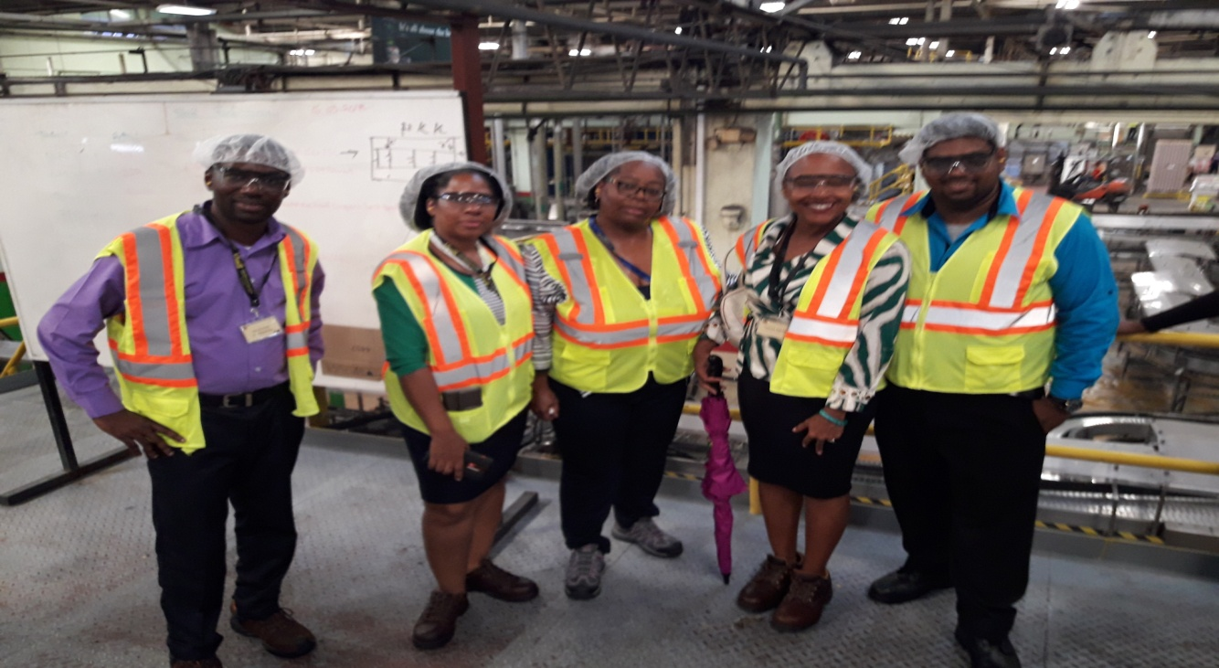
Representation
Representation in governance structures is one area which presented an opportunity for the youth. The delegation heard from several young people who were satisfied with the representation they received from youth organizations, training facilities, local government and stakeholders, they also shared views and interests on national and local stages. Young People feel that they are often treated with disdain; ill- considered in terms of competence and generally thought of as lazy and incompetent and they feel that they are not listened to, especially by the state. Synergy among youth organizations and good representation would correct these negative impressions of young people and act as an influence in the public arena to create conditions that would be more conducive to get young people into the world of work.
Transition from school to work
Transition from school to work is an important determinant of young people’s future livelihoods. Students who are emerging from the education system lack soft skills, such as time- management, inter-personal skills, language proficiency, computer literacy analytical and problem solving ability, innovativeness, creativity and willingness to learn. As noted earlier, educational attainment remains low and young people with a tertiary level education are the most likely to enjoy steady employment but the mismatch between young people’s skills and the needs of the employers remain high. This is a major challenge faced by young St. Lucian nationals that could be tackled by establishing partnerships between employers and educational institutions. Such partnerships could be underpinned by offering demand driven programmes.
Stakeholders lamented that when interns are trained with the required skills sets, they tend to leave and find work elsewhere after the training, leaving the stakeholders/ employers at a disadvantage where they have to train new recruits. Another representative from the Hilton Hotel lamented that interns/ trainees are free to seek employment elsewhere, we need to teach interns / trainees to fish. Some might migrate to enhance their skill sets, learn new skills to bring back to their country or further their education. The advantage to this movement is that they would return with new skill sets and serve in a higher capacity.
Programmes such as Housing Opportunities Production Employment (HOPE), the Youth Upliftment Through Education (YUTE) and HEART has stepped in to close the skills gap with their programmes. This can be emulated in St. Lucia; it is a success based on the success stories by the interns who proved that livelihoods improved and long term employment prospects of the youth improved.
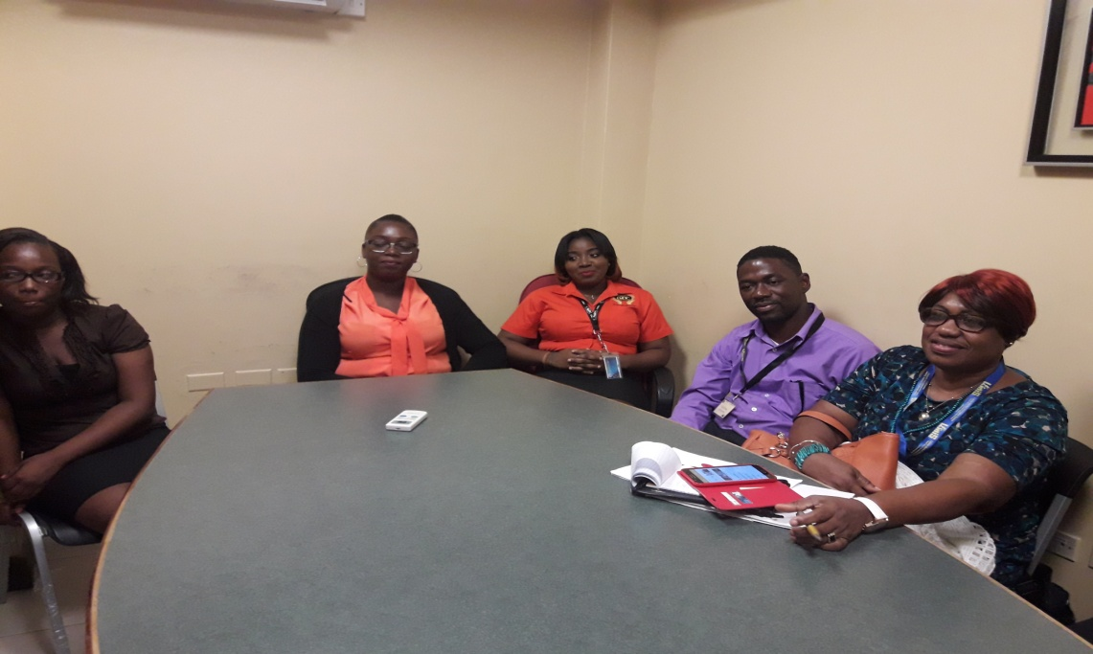

Next Steps
The Ministry of Infrastructure, Ports Energy & Labour will formulate a concept which will assist with youth unemployment, training and job placement.
Training will be provided by the training entities and the public sector to job seekers in an effort to enhance the skill sets sorely lacking in nationals, given the requests by employers for work permits. Also, an appeal was made to ensure the inclusion of soft skills that would make the workplace more amicable. In developing this concept, the following were deliberated on:
- Reactivating an updated version of Labour Market Information System (LMIS): Align job seekers/ applicants according to the training needs of the employers. The Labour Department of the Ministry of Infrastructure, Ports Energy & Labour will seek assistance to improve the operations of the public service by understanding the functions of St. Lucia’s Labour Market Information Systems (LMIS). The LMIS will be use as a register for potential school leavers/ job seekers and employers, it will facilitate job opportunities and career guidance. It is an internet-based system which permits increased access to labour market intelligence.

- Stakeholders identified the limitations with respect to hiring nationals i.e. time- management, inter-personal skills, language proficiency, computer literacy analytical and problem solving ability, innovativeness, creativity, willingness to learn, conflict resolution, emotional intelligence, team work, tolerance and responsibility. In St. Lucia, we hope to encourage the informal sector so that we can provide greater hope especially for youth employment. The lack of soft skills creates the skills gap, although we have a few institutions that provide specific training which caters to the needs of the work place. Yet, we still recognize a lack of skills, especially soft skills, which is a perennial complaint of employers. My opinion is the need for a radical shift in the schools’ curriculum to reflect the reality of the workplace. Unless we achieve this in our school, transition will not be smooth but the shocks will continue to be felt.

- Develop synergy among organizations and strengthen the department’s relationship with stakeholders.
- Stakeholders (hospitality industry, manufacturing, construction, private & public sectors)
- Training Institution (Sir Arthur Lewis Community College, TVET, National Research Development Foundation)
- Youth Groups (National Skills Development Centre, Centre for Adolescent Renewal & Education)
Organizations are reluctant to share information in term of statistics, limitations and training. Training Institutions and youth groups should partnership, work together and come up with systems and concepts to help bridge the skills gap.
- Introducing an On-The-Job Training programme like Jamaica, in the new initiatives will match trained and certified entry level interns with good job prospects in the private sector. Participants will normally be persons who have successfully completed their secondary school education or vocational certification, enhanced by training for job readiness, each trainee will be placed for a period of twelve (12) weeks.
The advantages of On- The –Job Training are the following:
- A simple method of learning: It is the most practical way to learn and even faster to understand the methodology adopted by the team and how they function.
- An economical way of learning.
- Get the feel right: trainees experience the actual set up of the work, giving them the feel of the working style right from day one.
- Immediate productivity: Every company wants to get their new trainers onboard as soon as possible rather than waste their resources on the bench. Be it on a project or not, they will have to pay them the salary. The intern is going to work within the team as a team member ensuring that some of the responsibilities will be assigned to them from day one. This will give assurance to the company that their resources are being used right from the day that they are appointed and hence making sure that immediate productivity is achieved and then there is no bench time.
- It is systematic: A systematic way of learning is far more effective than a random way of learning. Trainees have a stepwise training program when it comes to on the job training, the superior will be performing the task and he/she will be his or her shadow. This way the trainee would be clear on the stepwise execution of their task giving them the chance to learn systematically and helping them understand whether there can be any improvement in getting the work done faster and quicker.

- Collaboration with Work Permit Unit:
Another concept in collaboration with Work Permit Unit is the succession planning for the transfer of skills; where the employer will apply for work permits for positions (hot occupations) which require special skill sets. We would make an appeal to the employer/stakeholder to have the work permit holder or expatriates who are given work permits to train local persons so that St. Lucia can stop going overseas for experts and the intern will learn a new skill.

Examples of hot occupations:
- Managers
- Cooks specializing in: Chinese Cuisine, Italian Cuisine, Indian Cuisine
- Technicians: Engineering, Telecommunications
- Engineers: Mechanical/ Electrical, Civil
- Trade related workers with specialized skills: Electrician, Plummer, Welder
- Medical Workers: Dentist, Surgeon, Physician
- Accountants: Chattered, Auditor
- Machine Operator
- Hydroelectric Operator, boiler smith

Evaluation of the activity and recommendation

- Labour Market Information System (LMIS) needs to be promoted island wide so that the following persons/ organizations will benefit:
- Jobseekers
- Students
- Employers
- Policy makers
- Researchers
- Guidance Counsellors

Information will be available on:
- Resume’ writing
- Interview techniques
- Job search techniques career counselling
- Programmes and training opportunities

- Education and training institutions need to respond more quickly and become more adaptive to changes in the labour market.

- Information on website needs to be packaged appropriately to appeal to the stakeholders.

- The Tourism sector should receive official training and more time should be dedicated to classroom sessions experiential training.

- Elevate partnerships between education, training institutions and employers. More collaboration between companies and institutions so that students leaving these institutions will be equipped with the necessary skills needed in the work place.

- Introduce systematic development of teachers, trainers and Labour Ministry personnel on new approaches for skill development, also through role modelling and mentoring.

- Focus on quality and competitiveness of candidates. Ensure quality first.

- Break the silos between various youth employment initiatives and integrate developmental projects.

- During the delegation, representatives pointed to (4) pillars which promote low unemployment rate and lessen the skills gap which are:

- Strong labour market information – which is timely, accurate and forward looking. This serve as the base for curricular and career guidance.
- Incorporate soft skills, entrepreneurial skills, work experience into formal education system.
- Employers and educators share resources – such as staff, facilities, equipment, information and financial resources.
- Data management of Labour Market Systems – to track and monitor progress in employment, evaluate results and make data driven decisions on issues such as career choice, etc.

Conclusion

Support for young people seeking employment also comes from statutory bodies and specialized institutions that made presentations at the workshop/ exchange. They perform a very useful role in helping young people overcome the short comings of the educational system by supplying them with formal training and soft skills to make them more attractive to employers or more capable of setting up on their own. The experiences shared by workshop participants point to many stories, even when working with youth at risk. They discussed the skills and achievements of their young associates with employers directly and therefore placing them in employment.

Overall the workshop enhanced my appreciation for the critical role of officer in charge of local employment. We are in the business of shaping lives, assisting the unfortunate and bring relief to individuals. I gained much insight from the other participants, some of whom were senior to me in grade and experience. My intention moving forward is to give application to such knowledge and experience and enable the Department to serve the greater extent in the interest of St. Lucians.

