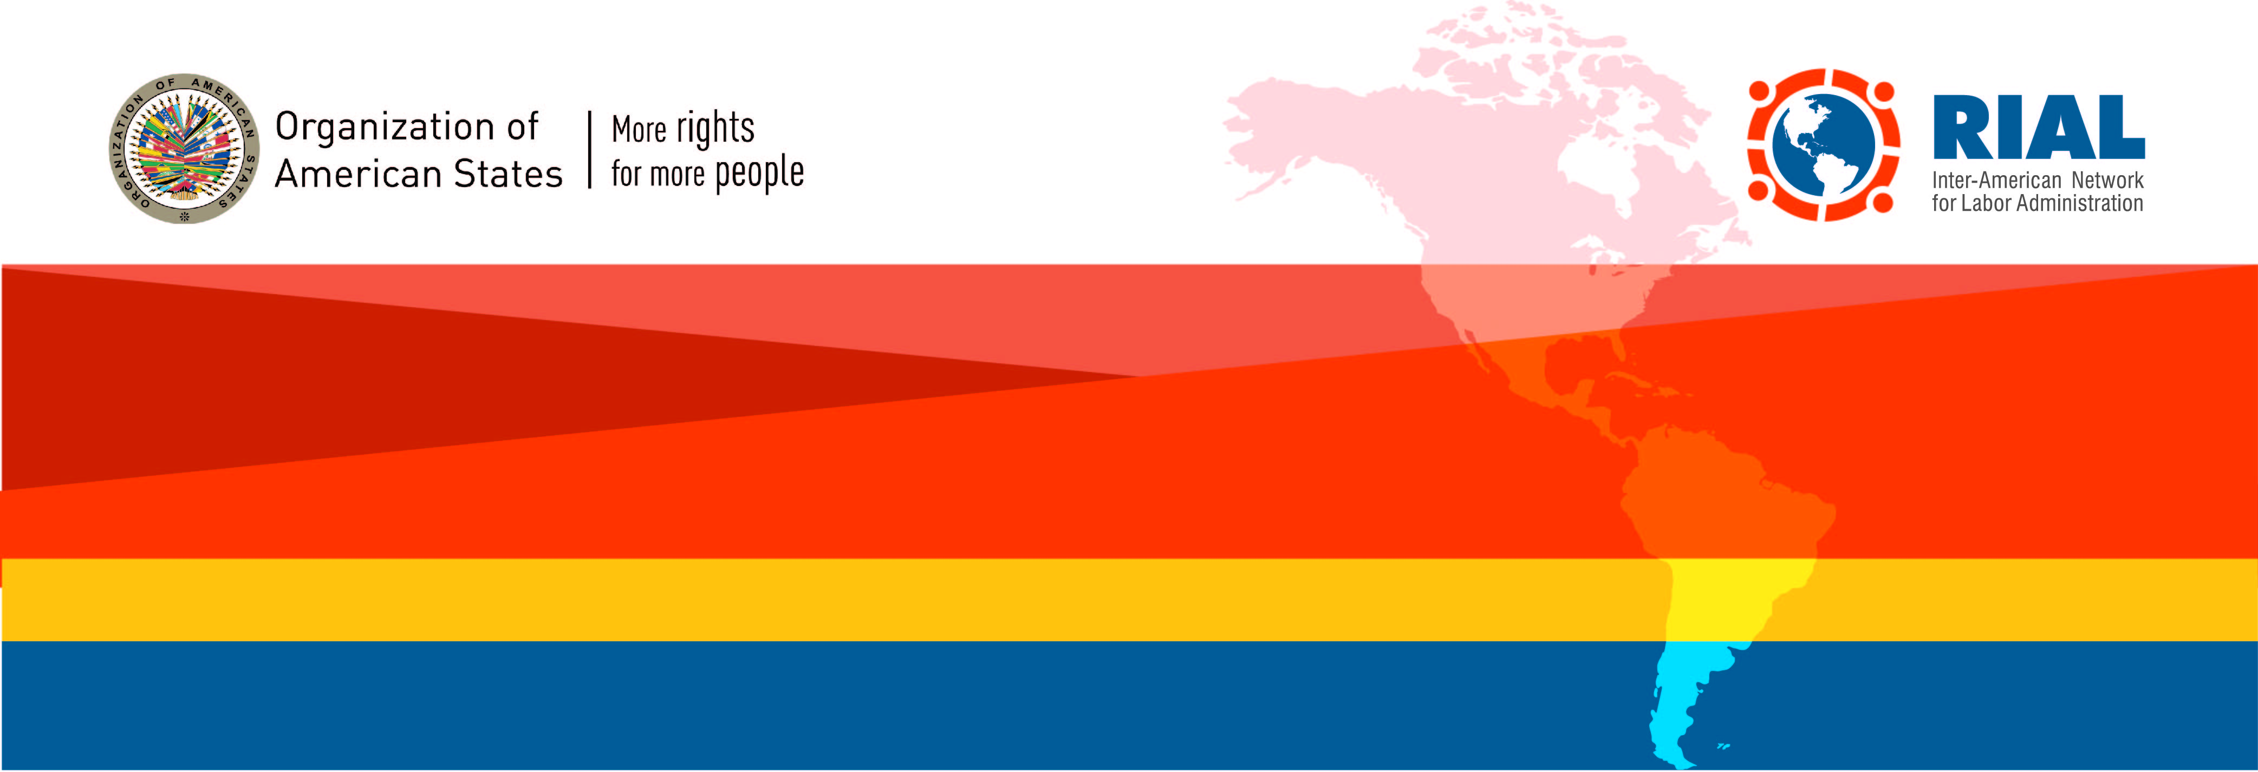
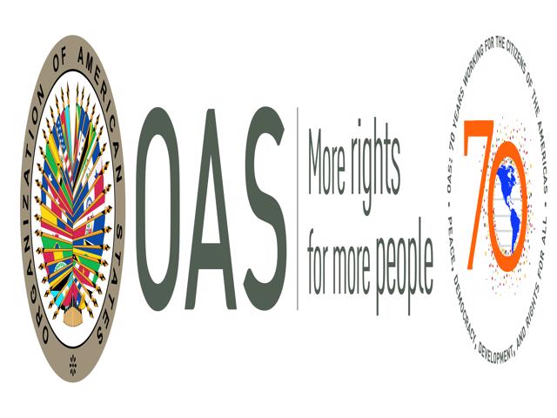
RIAL BILATERAL COOPERATION
12TH Call for Proposals – 2019
Submission deadline: February 25, 2019
¡EXTENDED! – New deadline: March 15th
Webinar to solve questions and support proposal development: February 6. Save the date!

Cooperation among Ministries of Labor of the Americas to strengthen their actions, policies and programs.
We invite all Ministries of Labor to submit proposals.

12th CALL FOR PROPOSALS - GENERAL GUIDELINES

objective AND Description

The objective of “Bilateral Cooperation” under the RIAL is to support institutional strengthening of the Ministries of Labor through direct technical cooperation among them. RIAL has organized 106 activities of this nature with excellent results that include the development of new services, the improvement of existing programs, and the redesign of training activities, among other. All the results and activities can be found in the webpage: www.rialnet.org.

Financial support provided by RIAL through this Call covers the travel expenses -airfare tickets and per diems (accommodation and meals) for officers of the Ministries of Labor. All activities will be funded by the RIAL Voluntary Contribution Fund, and those targeting specifically labor law compliance efforts will be funded by a Canadian contribution to the RIAL.

For the purpose of bilateral cooperation, the parties involved are:

  - Providing institution: Ministry of Labor that will share a specific program or expertise.

  - Requesting institution: Ministry of Labor that will analyze a specific program or practice, or that will receive technical cooperation.

The activities are generically called “Cooperation Activities” and can take any of the following 2 forms:

  - On-site advising or study tours: Representatives from the requesting institution travel to the providing institution to learn first hand about a program or initiative, or to receive technical cooperation. The visit/tour should be tailored to the needs of the requesting institution and as such, the funds will not be used to cover participation in general conferences or seminars.

  - Expert visit: Expert(s) from the providing institution travels to the requesting institution to provide specific training or technical assistance.

operation and procedures

- Identification of Cooperation Activity by the Parties Involved: The first step that should be taken by a requesting institution is to determine its international cooperation needs, based on its institutional priorities.

Example: A Ministry has among its priorities or strategic plan the restructuring or creation of a particular area, or the reform of certain internal procedures. To achieve these goals, it wishes to analyze similar experiences from other Ministries and receive international technical cooperation.

The second step is to identify the Ministry that can provide this technical support. To do so, Ministries may consult the RIAL Portfolio of Programs at www.rialnet.org and identify experiences that respond to their cooperation needs and priorities. They should also take advantage of the relationships among RIAL focal points as well as the information and contacts obtained during workshops and meetings of the OAS Inter-American Conference of Ministers of Labor (IACML), ILO or other relevant fora, where delegates have the opportunity to meet, exchange ideas and identify possible channels for further cooperation.

The RIAL focal points should negotiate the cooperation proposals and support technical areas of their Ministries in identifying experiences and potential providers, based on their institutional strengthening needs and priorities. The Technical Secretariat, at the Executive Secretariat for Integral Development of the OAS (SEDI/OAS), will support the identification of possible providing institutions and will facilitate the interaction between Ministries that do not already have direct communication channels.

The Technical Secretariat will organize a Virtual Information Session (webinar) in English on February 6th to assist Ministries in the presentation of proposals, and which may contribute to identifying possible partners.

- Request for Funding: Each Requesting institution must submit to the SEDI/OAS, through its RIAL focal point and Permanent Mission to the OAS, a request for funding for each cooperation activity it wishes to undertake. This request should contain the following documents:
    - Request Form – Attached to this document.
    - A letter from the requesting institution, signed by the Minister or a High-ranking official, sending the Request Form and stating the commitment to provide a Final Report of the cooperation activity.
    - A letter from the providing institution, signed by the Minister or a high-ranking official, confirming the commitment to either receive members of the requesting institution to analyze some program or initiative or to send an expert(s). This letter should also include the commitment of the providing institution to feed into the Final Report prepared by the requesting institution.

Complete applications should be received no later than March 15th, 2019.

- Selection of Cooperation Activities to be funded: The OAS will receive and select the activities to be funded, based on the criteria listed below. Selections are final and not subject to appeal.

The criteria to select the activities are:
  - Pertinence and timeliness of the cooperation - the justification/rationale for the activity shows why cooperation is required at the time
  - Objectives are clear, pertinent and achievable
  - Clarity and relevance of the participants’ profiles
  - Explicit commitment on the part of the parties involved
  - Degree of relevance of the topic for the IACML
  - Priority will be given to proposals arising from activities of the RIAL and the IACML, and to those that are receiving co-financing from the requesting institution

Note on ineligibility: The Ministries that have not submitted final reports from previous activities or follow-up surveys will not be eligible to receive new cooperation resources.

- Undertaking and Funding of Cooperation Activities: Activities of this call for proposals will take place between June and December, 2019, and those that are not completed at the end of this period will be canceled. The Technical Secretariat, after announcing the proposals selected, will contact each of the Ministries involved to jointly set the dates, draft the agendas and coordinate all logistical and technical aspects.

Each activity’s agenda should respond to the interests and needs of the requesting institution and to the strengths of the providing institution; therefore, it should be drafted jointly by the officers that will participate in the cooperation activity from both institutions, in coordination with the RIAL focal point of each Ministry and the Technical Secretariat.

Please note that the RIAL reserves the right to review and/or cancel an activity in case the participants’ profiles initially indicated in the Request Form are modified considerably.

- Final Reports: Within one month after each of the activities takes place, the requesting institution should produce a Final Report, describing the main outcomes, achievements and lessons learned, as well as future steps to be taken. The providing institution will provide input to and feedback on the report before it is submitted to the Technical Secretariat.

- Follow-up: Six months after the completion of the activity, the OAS will send a follow-up survey to identify the results and impacts of the cooperation. The OAS will prepare a summary report of completed activities, and the achieved results will be presented during the IACML meetings.

A Webinar will take place on February 6th in English (February 5th in Spanish) to address questions and support proposal development. In the meantime, for any questions please contact María Claudia Camacho, RIAL Coordinator at mcamacho@oas.org, Tel: (1202) 370-4952 or Guillermo Calzada, RIAL project officer at gcalzada@oas.org, Tel: (1202) 370-9717
RIAL BILATERAL COOPERATION
REQUEST FORM – 12th CALL FOR PROPOSALS - 2019

To be sent no later than March 15th, 2019 to:

Executive Secretariat for Integral Development (SEDI), OAS
Att. Maria Claudia Camacho, Chief of the Labor & Employment Section, RIAL Coordinator
E-mail: trabajo@oas.org; mcamacho@oas.org - Tel: (1202) 370-4952/9717

To complete your submission please send the following along with this request form: Letter from the requesting institution and letter from the providing institution with the details indicated in the Guidelines of this Call for proposals (section “2: Request for funding”)

(The area of the cells is expandable. Please use all the space you consider necessary)
Requesting institution (include country): | Providing institution (include country):
Type of Cooperation activity (select one):  ___ On-site advising or study tour  ___ Experts visit | Thematic area of cooperation activity requested:
Justification: Briefly specify why this cooperation is needed at this point in time, state the specific challenges your Ministry is facing in the area that is covered by this cooperation activity and the reasons for choosing the providing institution.
General objective and specific objectives of this cooperation:
Expected results of this cooperation:
Proposed contents for this cooperation: Describe the activity (on-site advising or experts visit), specifying its contents as much as possible (programs to be analyzed, Ministry’s areas to visit, etc.)
Participants’ profiles: Indicate which Ministry’s officers will be participating in this cooperation (up to 3 officers). Specify the titles and main responsibilities; it is not necessary to provide names. These profiles cannot be modified during the planning of the activity∗
Specification of other support: Please indicate if your institution has requested or received financial or technical assistance from international agencies or governments in the area of this cooperation.
Identification of Providing institution: Please indicate how the providing institution was identified, for example RIAL Portfolio of Programs, direct contact, publication or Workshop/Seminar.
Co-financing: Will additional funding be provided (other than RIAL)?  ___ No  ___ Yes. Please specify: ___________________ |  | Suggested dates (between June and Dec. 2019):  Please indicate at least two alternatives agreed upon with the Providing institution
Contact information (Name, title, e-mail and phone of individual preparing this request):

RIAL focal points are generally the offices of international affairs or cooperation of the Ministries of Labor. An updated list of focal points is available in the RIAL website: www.rialnet.org .
 Please note that the RIAL reserves the right to review and/or cancel a bilateral cooperation activity in case the participants’ profiles initially indicated in the Request Form are modified considerably.

